## 

## 

## Samuel R. Burton Professional Development and Media Center

4525 Danito Ct, Chino, CA 91710

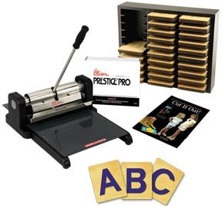

The Chino Valley Unified School District offers a remarkable media center for parent volunteers. This media center provides a wide range of supplies that volunteers can freely utilize in the classroom for decorations and parties..

Volunteers are welcome to use the wide range of die cuts at no charge. The other services like lamination, and supplies such as construction paper, butcher paper, and so much more are available for purchase at affordable prices.

**Please note that all purchases of supplies must be made in CASH.**

Any purchase made for the PTA can be reimbursed.

This center has two amazing employees who are happy to help teach you

about everything they have to offer.

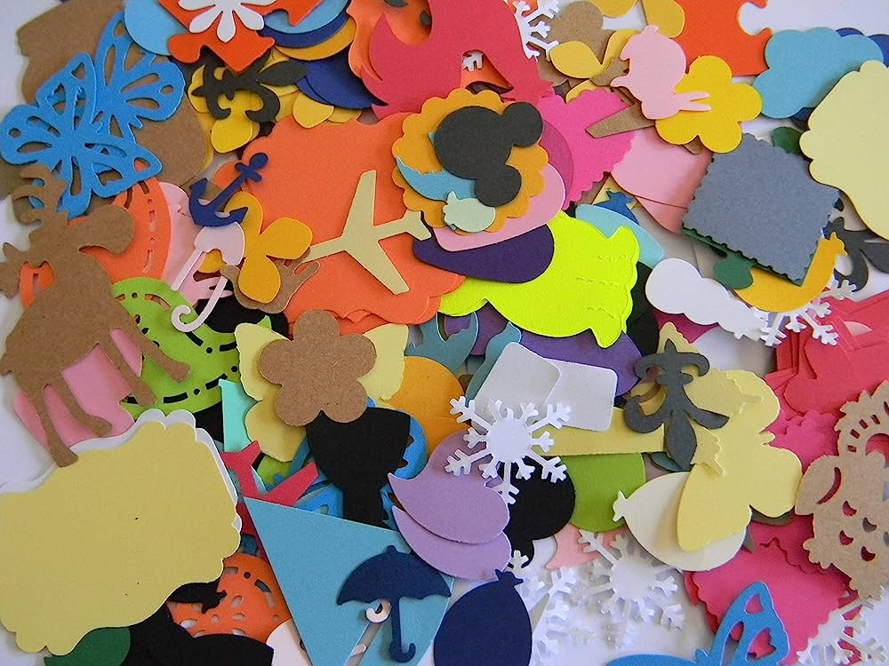

A list of supplies and die cuts can be found here:

<https://www.chino.k12.ca.us/Page/2558>